Experiment 6: AI-Based Code Completion: Working with suggestions for classes, loops, conditionals.

NAME : M.SRIVALLI
ROLL_NO: 2503A52382

Task Description #1 (AI-Based Code Completion for Loops)
Task: Use an AI code completion tool to generate a loop-based program.
Prompt:
“Generate Python code to print all even numbers between 1 and N using a loop.”
Code:
N = int(input("Enter N: "))

for i in range(1, N + 1):
if i % 2 == 0:
print(i)
Output :
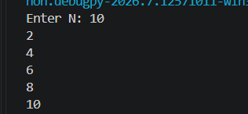

Task Description #2 (AI-Based Code Completion for Loop with Conditionals)
Task: Use an AI code completion tool to combine loops and conditionals.

Prompt:
“Generate Python code to count how many numbers in a list are even and odd.”

Output :
numbers = [1, 2, 3, 4, 5, 6, 7, 8, 9, 10]

even_count = 0
odd_count = 0

for num in numbers:
if num % 2 == 0:
even_count += 1
else:
odd_count += 1

print("Even numbers count:", even_count)
print("Odd numbers count:", odd_count)

Output :
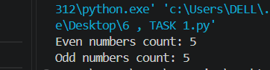

Task Description #3 (AI-Based Code Completion for Class Attributes Validation)
Task: Use an AI tool to complete a Python class that validates user input.

Prompt:
“Generate a Python class User that validates age and email using conditional statements.”

Code :
class User:
def __init__(self, age, email):
self.age = age
self.email = email

def validate(self):
if self.age >= 18:
print("Age is valid")
else:
print("Age is invalid")

if "@" in self.email:
print("Email is valid")
else:
print("Email is invalid")

age = int(input("Enter your age: "))
email = input("Enter your email: ")

user1 = User(age, email)
user1.validate()

Output :
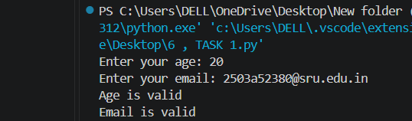

Task Description #4 (AI-Based Code Completion for Classes)
Task: Use an AI code completion tool to generate a Python class for
managing student details.
Prompt:
“Generate a Python class Student with attributes (name, roll number, marks) and methods to calculate total and average marks.”Expected

Code :
class Student:
def __init__(self, name, roll_number, marks):
self.name = name
self.roll_number = roll_number
self.marks = marks

def calculate_total(self):
return sum(self.marks)

def calculate_average(self):
return self.calculate_total() / len(self.marks)

name = input("Enter student name: ")
roll_number = int(input("Enter roll number: "))

marks = []
for i in range(3):
mark = float(input(f"Enter marks for subject {i + 1}: "))
marks.append(mark)

student1 = Student(name, roll_number, marks)

print("\nStudent Details")
print("Name:", student1.name)
print("Roll Number:", student1.roll_number)
print("Total Marks:", student1.calculate_total())
print("Average Marks:", student1.calculate_average())

output :
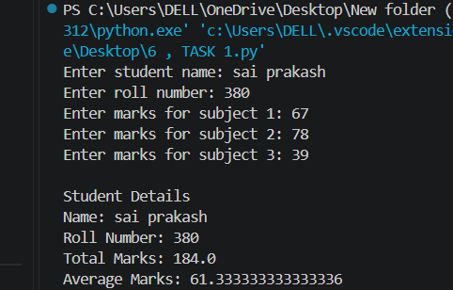

Task Description 5 (AI-Assisted Code Completion Review)
Task: Use an AI tool to generate a complete Python program using classes, loops, and conditionals together.
Prompt:
“Generate a Python program for a simple bank account system using class, loops, and conditional statements.”
Code :
class BankAccount:
def __init__(self, name, balance):
self.name = name
self.balance = balance

def deposit(self, amount):
self.balance += amount
print("Amount deposited successfully.")

def withdraw(self, amount):
if amount <= self.balance:
self.balance -= amount
print("Amount withdrawn successfully.")
else:
print("Insufficient balance.")

def check_balance(self):
print("Current Balance:", self.balance)

name = input("Enter account holder name: ")
balance = float(input("Enter initial balance: "))

account = BankAccount(name, balance)

while True:
print("\n--- Bank Menu ---")
print("1. Deposit")
print("2. Withdraw")
print("3. Check Balance")
print("4. Exit")

choice = int(input("Enter your choice: "))

if choice == 1:
amount = float(input("Enter deposit amount: "))
account.deposit(amount)

elif choice == 2:
amount = float(input("Enter withdrawal amount: "))
account.withdraw(amount)

elif choice == 3:
account.check_balance()

elif choice == 4:
print("Thank you for using our bank.")
break

else:
print("Invalid choice. Please try again.”)

Output:

